Chapter 4: Lifestyle
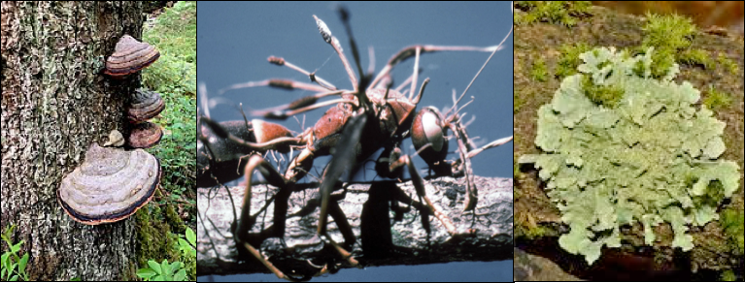
Fig.4.1 Different fungal lifestyles, left to right, saprophytic fungus growing on dead wood, parasitic fungus colonized insect body and is producing a mushroom, and a mutualistic fungus that has a symbiosis with many other organisms including algae and/or cyanobacteria. Images from wikipedia.

Fungal lifestyles are an important aspect of plant-fungi interactions which will determine a farmers relationship with each fungal species they encounter. Many fungi are helpful to farmers. Some serve to cycle nutrients from organic matter and access those trapped in parent rock material. Others colonize the surfaces and internal tissues of plants. Even most of these benefit their host plant in myriad ways, or at the least do not cause harm. Often, the fungal lifestyle most familiar to farmers is one that manifests as a conspicuous loss of crop to disease. Disease causing fungi of Cannabis are those that live as pathogens, causing harm to their host plant in order to obtain nutrition from it. Understanding the different strategies of fungi on your farm will allow more adept control over their manipulation so that pathogens may be minimized while beneficials can be optimized.
Fungi are heterotrophic, reliant on acquiring nutrients from the environment they live in for their metabolic demands. As such, fungi typically fit among three different types of lifestyles that they use to get nutrients. Those lifestyles are saprophytic (fungi that degrade dead organic material), parasitic (fungi that live on another living organism and cause the host some degree of harm) and mutualistic (meaning there are benefits to both the fungus and its symbiont). In addition to these lifestyles, there are some predacious fungi that derive all or part of their nutrients from carnivory; they do so by trapping soil inhabiting invertebrates using specialized hyphae. Many fungi readily switch roles among these trophic strategies from parasite, to mutualist, to saprophyte, to predator, and back again as it suits their needs and abilities.
Saprophytes are very important in many ecosystems because they are the ‘grand recyclers’ and take dead material and make those nutrients available for other organisms to utilize. Therefore, saprobes play an important role in nutrient cycling. This makes these fungi very important for organic Cannabis agriculture. The garden giant (Stropharia rugosa-annulata) is one such fungus that is often incorporated into raised beds. The mycelium is mixed with pasteurized straw or wood chips and then used to cover the soil on the garden bed. This not only cools the soil surface temperature and reduces weeds, but it also cycles nutrients through the soil system to your plants. This occurs because fungi are constantly excreting enzymes and breaking down complex compounds into simpler molecules that can eventually be assimilated by the plants. The garden giant fungus is also relatively easy to grow outdoors and produces an incredibly tasty mushroom, making it a perfect companion for outdoor plantings with Cannabis. Though, many other saprophytic fungi may benefit plants similarly in myriad ways, such as improving nutrient cycling, soil structure, water retention, and competing with disease agents. It should be noted that care should be taken to ensure adequate nitrogen availability when adding low nitrogen mulch material; in the short term, nitrogen will be pulled from the top layers of the soil by saprophytes as they colonize and degrade new mulch.
Other saprophytic fungi include edible, mushroom-producing fungi such as oyster mushroom, shitake mushroom, and button mushroom. Many soil fungi, including Trichoderma and Penicillium species, are saprophytes that do not produce mushrooms but play key roles in the conversion of organic matter into usable nutrients. If your soil lacks fungal diversity, high quality compost full of soil microbes is an efficient method for adding fungi back to soils.
In addition to decomposing materials and aiding in nutrient cycling, many soil fungi can produce novel metabolites that can influence the soil biology and can, therefore, affect plant growth. Whereas saprophytic fungi grow on dead organic matter, parasitic fungi grow on living organic matter.
Parasitic fungi can grow on many different organisms, ranging from animals to plants, to even other fungi (Fig. 4.1). By definition, parasitic fungi are fungi that derive their nutrients from another living organism with no apparent benefit to the host. Because parasites require a living victim to persist, a well-adapted and specialized parasite rarely kills its host! There are some fungi that act as human pathogens and can cause serious illness, especially in patients that already have a compromised immune system. For instance, athlete's foot and ringworm are both diseases which affect humans that are caused by fungi in the genus Arthroderma. Then there are a lot of other
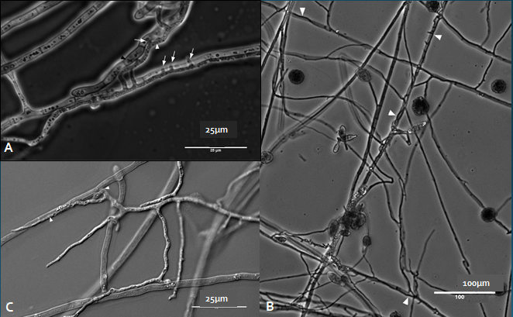
Figure 4.2. An example of a mycoparasitic interaction where Alternaria alternata is attacking the hyphae of Eppicoccum nigrum seen with phase (A and B) and differential contrast interference (C) microscopy.

fungi that act as pathogens to plants. Some of these species of fungi are generalists and can live on a variety of host plants, whereas other species are specialists, growing only on specific host plants. For the Cannabis plant, there are a variety of fungal species that can act as pathogens and they range in the amount of damage to the host (Table 4.1).
Though there are a number of fungi that act as parasites, there are also many that have beneficial relationships with other organisms. This type of symbiosis, where two organisms interact physiologically to form a mutually beneficial relationship, is called mutualism. For example, a lichen is a mutualism where a fungus acts as a mycobiont and an algae or cyanobacteria will act

Table 4.1. A few of the many important saprophytes, parasites, and mutualists for Cannabis growers
Saprophytes | Parasites | Mutualist
Soil:  - Penicillium spp.  - Aspergillus spp.  - Trichoderma verde  - Trichoderma hazarium  Wood Rot:  - Pleurotus spp.  - Stropharia rugosoannulata  - Pilocybe spp. | Plant pathogens  - Fusarium oxysporum  - Botrytis cinerea  - Golovinomyces ambrosiae  - Podosphaera macularis  - Septoria cannabis  - Alternaria alternata  Mycoparasitic  - Trichoderma verde  - Trichoderma hazarium | Arbuscular (Endo-) Mycorrhizae:  - Glomus spp.  - Rhizophagus intraradices  - Funneliformis mosseae  - R. irregularis  Berruti et al 2015  Mucormycotina Fine Root Endophytes  Endophytes  - Penicillium spp.  - Trichoderma spp.
as a photobiont; together they create one organism, a lichen. Another example of this are mycorrhizal fungi. Mycorrhizal (myco- meaning fungus and -rhiza meaning root) fungi form associations with the roots of many different plants and help deliver the plant water, minerals, and nutrients (in particular phosphorus) and in return the plants gives the fungus sugars that it makes in photosynthesis.
A fourth type of interaction that we see fungi engage in is called commensalism. This is when one organism uses another organism to its benefit, without causing harm to the other organism. An example of this is when an epiphytic orchid is growing high up in the crevasse of a tree, the orchid has an advantage over other orchids because it is higher up and therefore is closer to sunlight, whereas the tree is not meaningfully affected positively or negatively.
Although these four different types of interaction or lifestyles may seem clearly defined, realistically in nature these relationships are on a continuum. These four different lifestyles that we just described (Saprophyte, parasite, mutualism and commensalism) are all terms that were created by humans to help us understand nature. However, nature is not confined to such borders and therefore we see some organisms that are mutualists at one point in their life, and then they switch to being a parasite, and eventually they act as a saprophyte because the organism is consuming the dead host that it just parasitized. So, although we do our best to describe and make sense of nature, we always have to remind ourselves that nature doesn't always follow our rules.

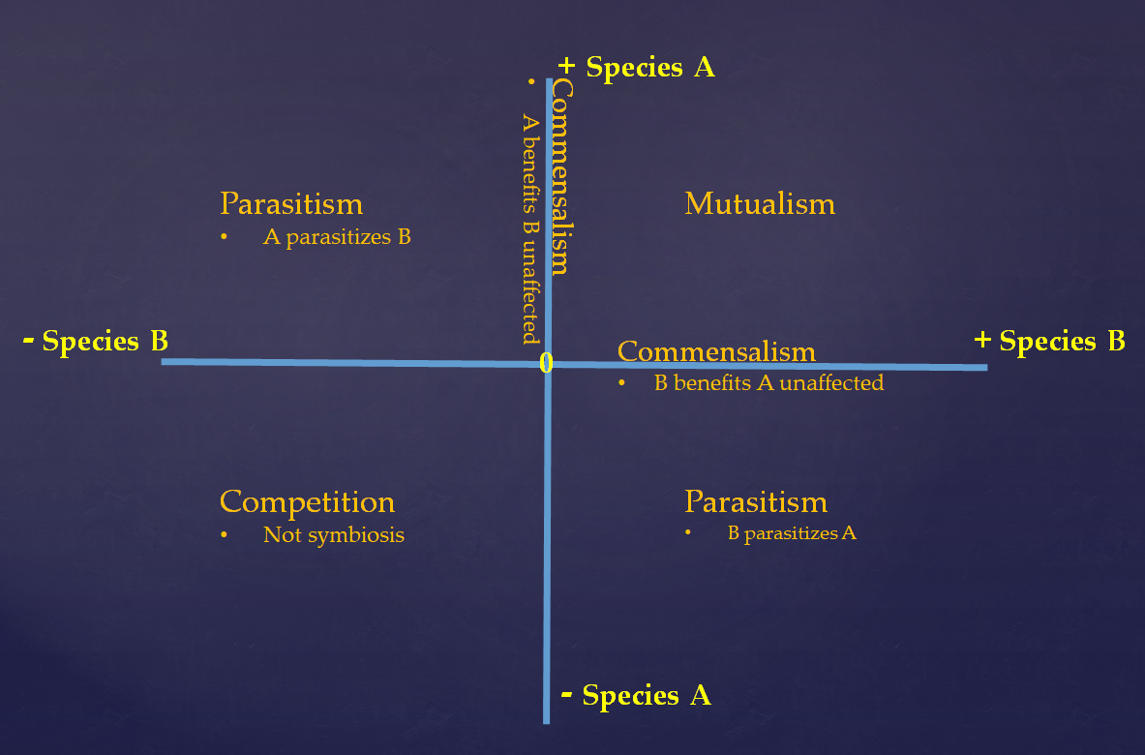
Figure 4.3. Symbiosis in a quadrant to depict the continuum of interactions that two or more organisms may display in regard to each other.
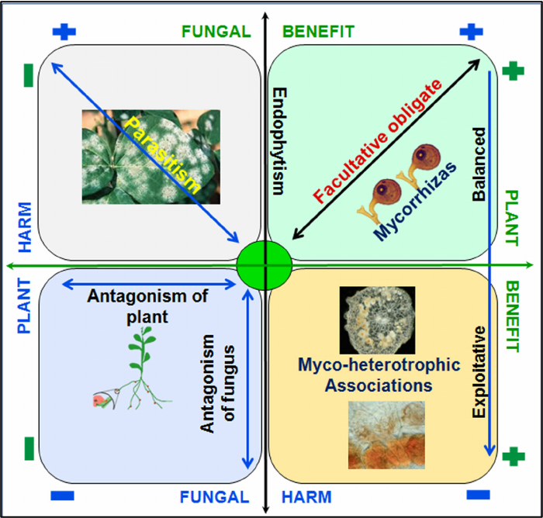
Fig 4.4

